Nama : Isnaini Dewanti

NIM : 10650011

ERD SIA SMP 10 Yogyakarta

Tabel

siswa

|  |
| --- |
| nis |
| nm_siswa |
| password |
| angkatan |
| jk |
| agama |
| alamat |
| nm_wali |

guru

|  |
| --- |
| nip |
| nm_guru |
| password |
| jk |
| agama |
| alamat |
| status |
| keterangan |

mapel

|  |
| --- |
| kd_mapel |
| nm_mapel |
| kd_kelas |
| kd_guru |

kelas

|  |
| --- |
| kd_kelas |
| nis |
| kelas |
| thn_ajaran |

nilai

|  |
| --- |
| no |
| nis |
| thn_ajaran |
| semester |
| kd_mapel |
| kkm |
| nilai_rapor |

absensi

|  |
| --- |
| no |
| nis |
| kd_kelas |
| tanggal |
| hadir |
| jml_sakit |
| jml_izin |
| jml_alpa |
| thn_ajaran |

jadwal

|  |
| --- |
| nis |
| kd_mapel |
| hari |
| jam |
| kd_guru |
| ruang |
| thn_ajaran |

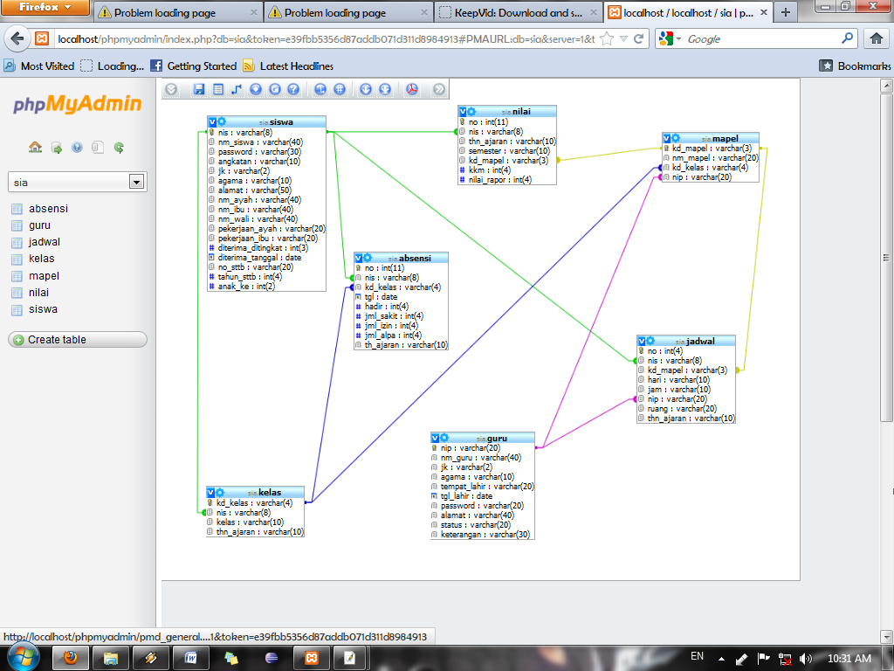

Diagram ER

kelas

mempunyai

absensi

melihat

guru

mapel

jadwal

nilai

melihat

mengolah

mempunyai

melihat

mengajar

siswa